

**CS 406**

# Programming Practices

**LAB FILE**

**SUBMITTED TO: SUBMITTED BY:**

**Mr. CHANDAN MUKHERJEE Animesh Sharma**

       Asst. Professor CS-A (4thsemester, 2nd year)

      Dept. of Computer Science & Engineering (0905CS201023)

      ITM GOI, Gwalior

**List of Program**

|  |  |  |  |
| --- | --- | --- | --- |
| S.NO. | Name Of Experiment | Date | Sign |
|  |  |  |  |
|  |  |  |  |
|  |  |  |  |
|  |  |  |  |
|  |  |  |  |
|  |  |  |  |
|  |  |  |  |
|  |  |  |  |
|  |  |  |  |
|  |  |  |  |
|  |  |  |  |
|  |  |  |  |
|  |  |  |  |
|  |  |  |  |
|  |  |  |  |
|  |  |  |  |
|  |  |  |  |
|  |  |  |  |
|  |  |  |  |

**Ques. 1: -- To display Nth Prime Fibonacci Number prime Fibonacci series - 2, 3, 5, 13, 89, 233, 1597, 28657, 514229. I/P – 3 I/P - 6 O/P – 5 O/P – 233**

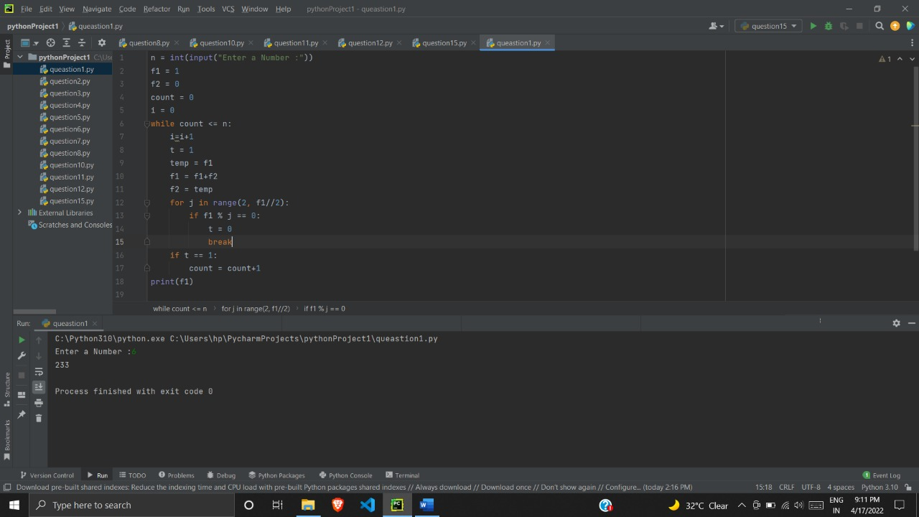

**Ques. 2: -- Consider the series: 1, 2, 1, 3, 2, 5, 3, 7, 5, 11, 8, 13, 13, 17, … This series is a mixture of 2 series – all the odd terms in the series form a Fibonacci series and all the even terms are the prime numbers in ascending order. Write a program to find the Nth term in the series. The value N in a positive integer that should be read from STDIN. The Nth term that is calculated by the program should be written to STDOUT. Other than the value of Nth term, no other characters/string or message should be written to STDOUT. For example, when N=14, the 14th term in the series is 17.**

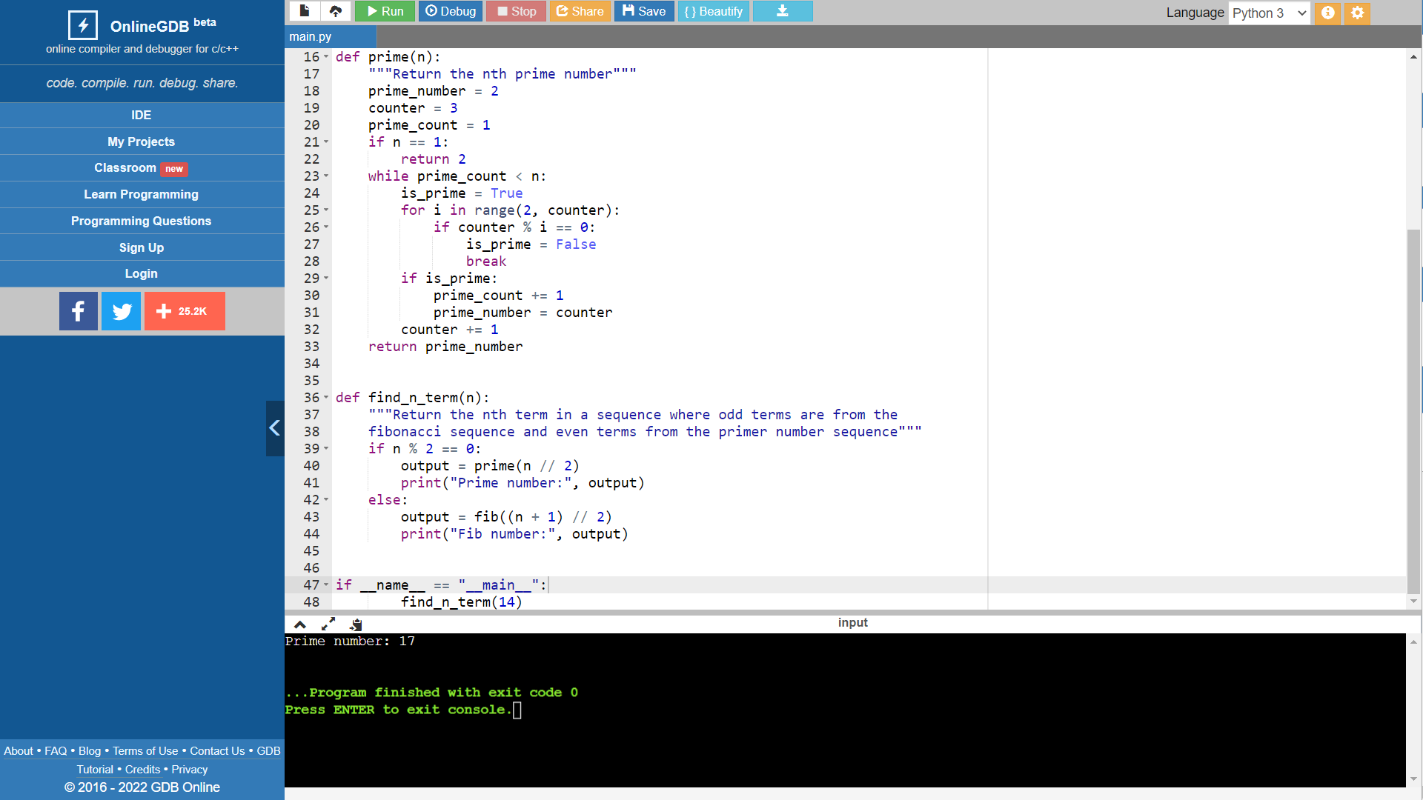

**Ques. 3: -- Display and count all Twin Prime within a range. Range value will be given by user.**

**I/P -> 2,20**

**O/P -> 3,5**

**5,7**

**11,13**

**17,19**

**4**

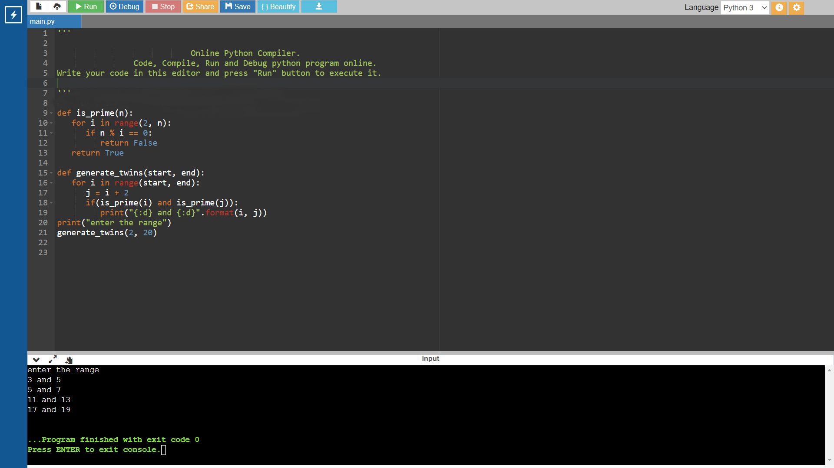

**Ques. 4: -- Read a List of Words and Return the Length of the Longest One and display the word also**

**I/P -> 4 (No of Words)**

**HI**

**Hello**

**Take Care**

**Bye**

**O/P- 9 Take Care**

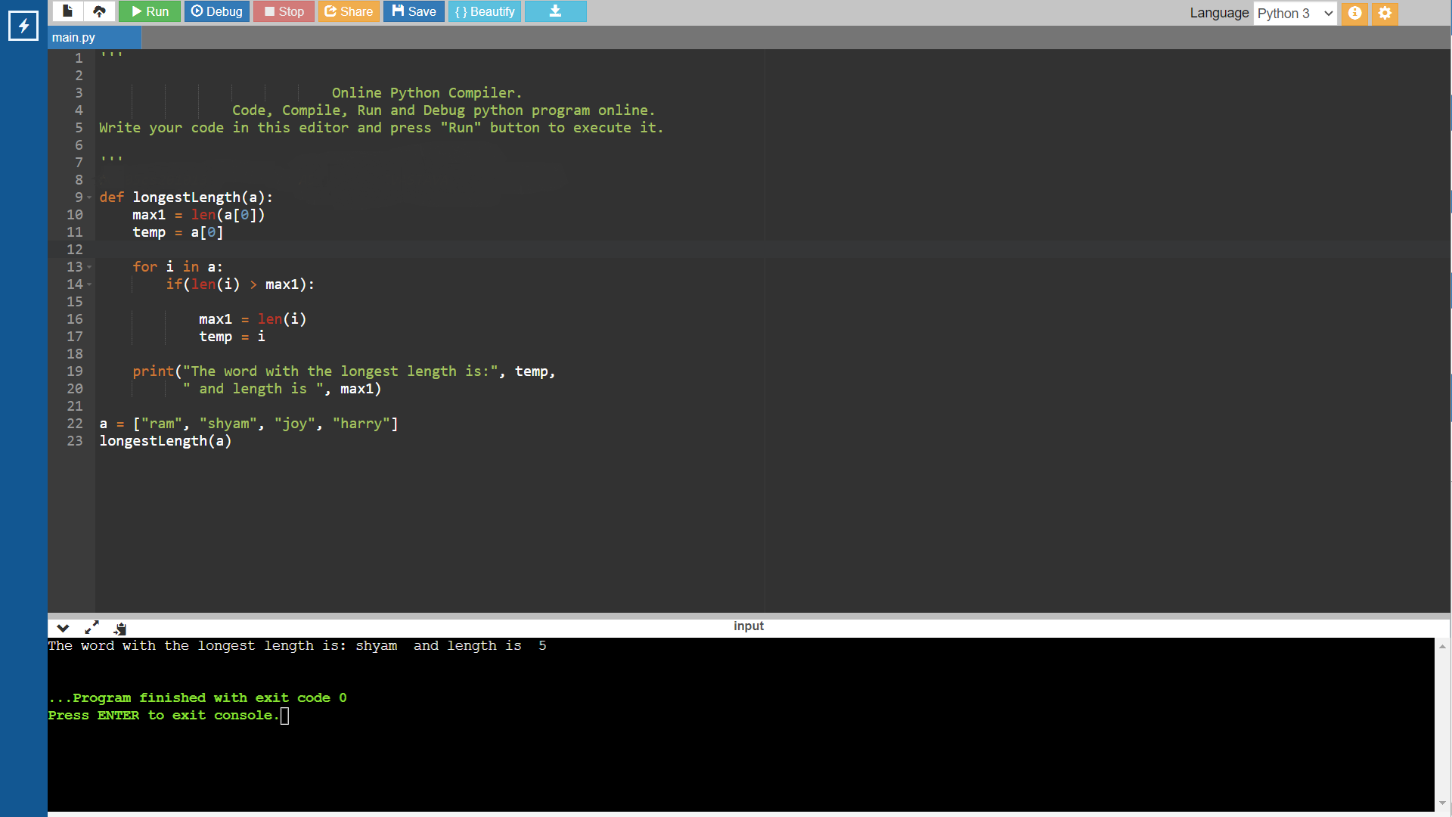

**Ques. 5: -- Displays which Letters are in the First String but not in the Second.**

**I/P -> Book Cook**

**O/P -> B**

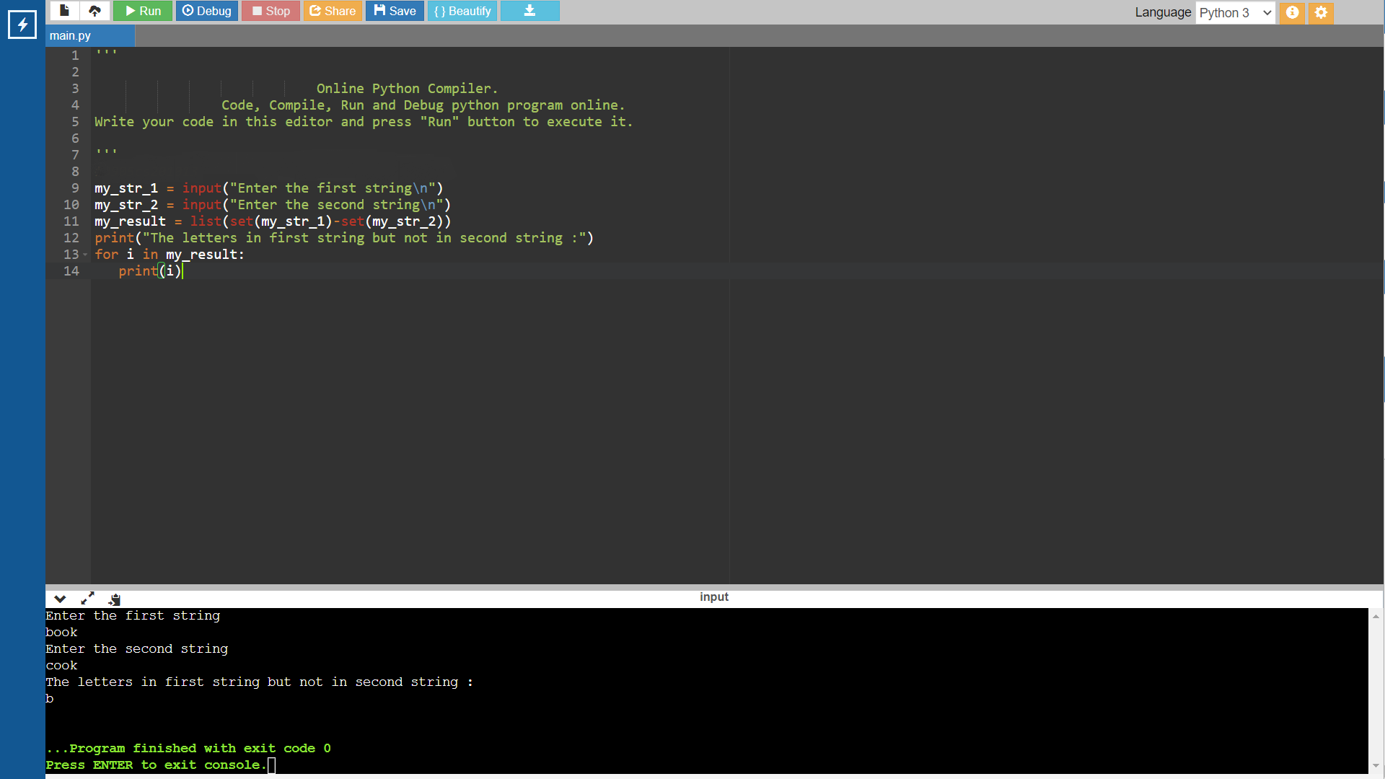

**Ques. 6: -- Check 2 Strings are Anagram or not?**

**I/P -> READ DEAR**

**O/P -> ANAGRAM**

**I/P -> READ READ**

**O/P -> NOT ANAGRAM**

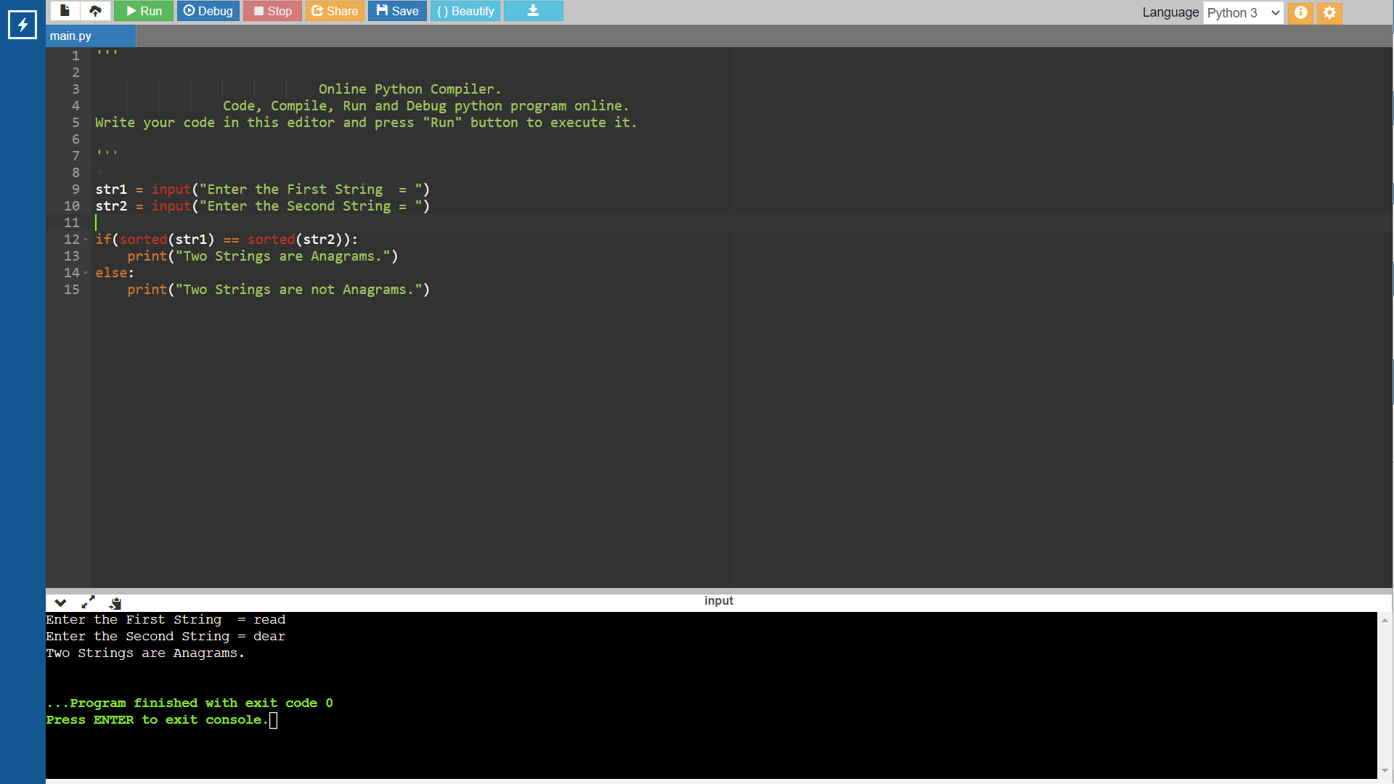

**Ques. 7: -- Find 2nd Greatest No From a user input List. Greatest no have multiple occurrence.**

**I/P -> [20,10,20,6]**

**O/P -> 10**

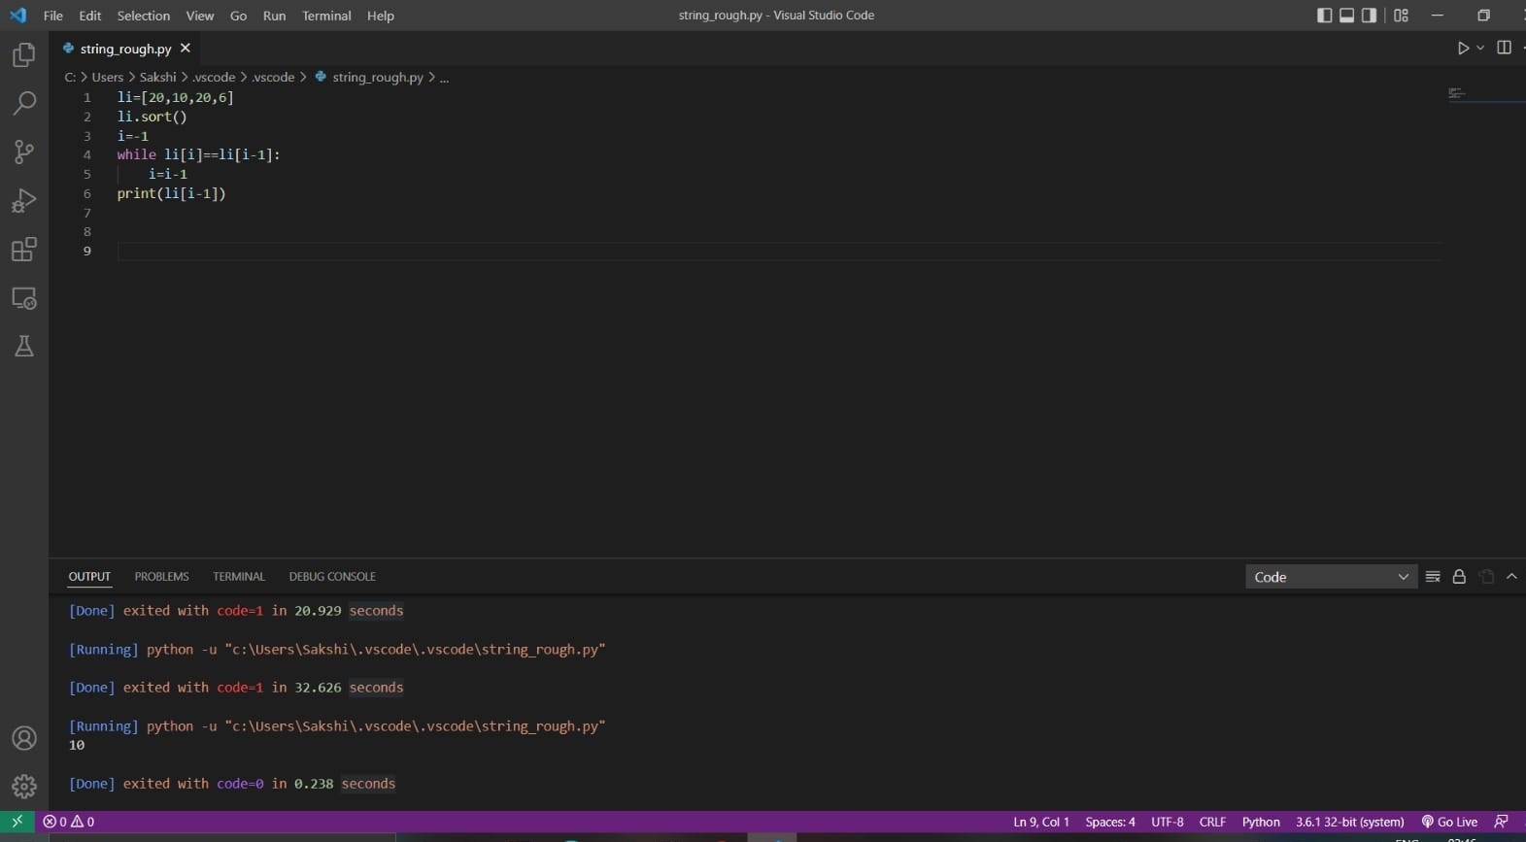

**Ques. 8: -- Find the no of occurrence of a word in a String. Original word and Searching word will be enter by the user.**

**I/P -> book pen pencil book**

**book**

**O/P -> 2**

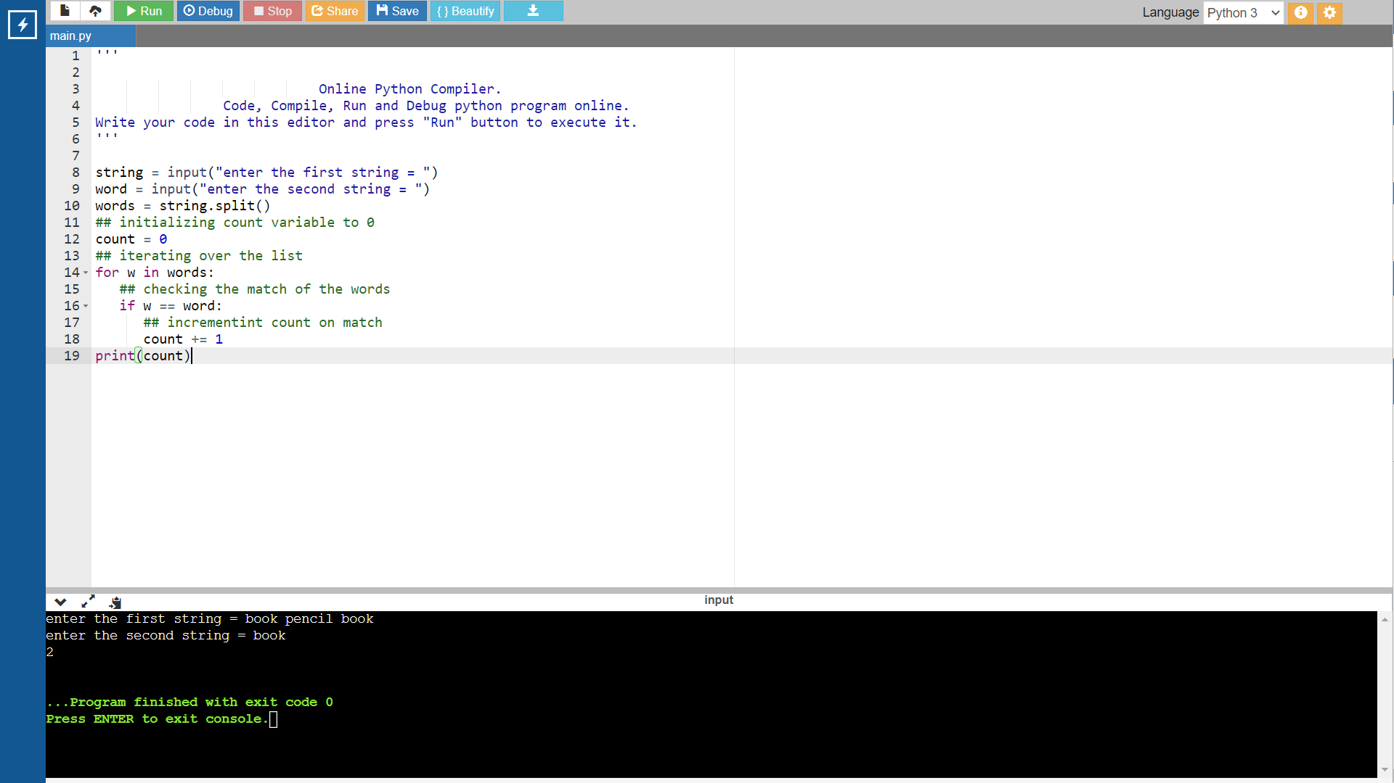

**Ques. 9: -- Convert Date to Day. User will input any date; program will show which DAY it is.**

**I/P - 12/04/22 O/P – TUESDAY**

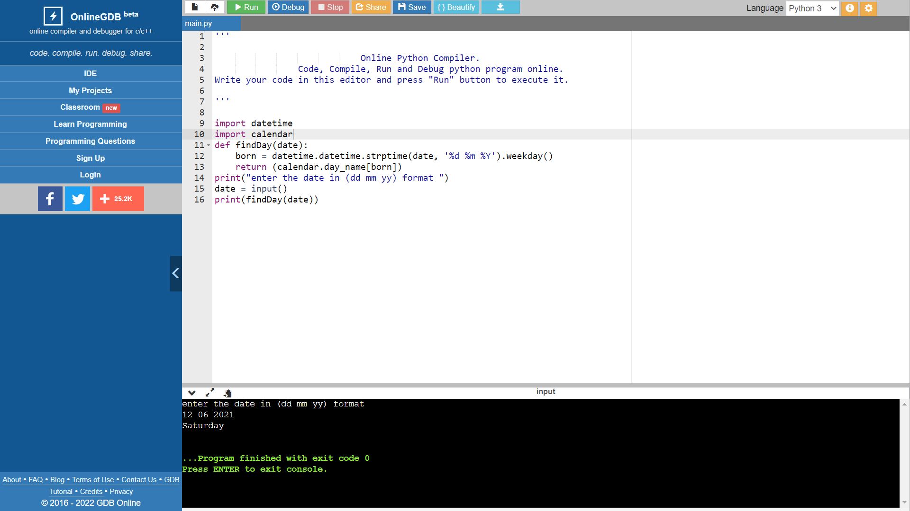

**10. Given a maximum of 100 digit numbers as input, find the difference between the sum of odd and even position digits**

**Case 1**

**Input: 4567**

**Expected Output: 2**

**Explanation : Odd positions are 4 and 6 as they are pos: 1 and pos: 3, both have sum 10. Similarly, 5 and 7 are at even positions pos: 2 and pos: 4 with sum 12. Thus, difference is 12 – 10 = 2**

**Case 2**

**Input: 5476**

**Expected Output: 2**

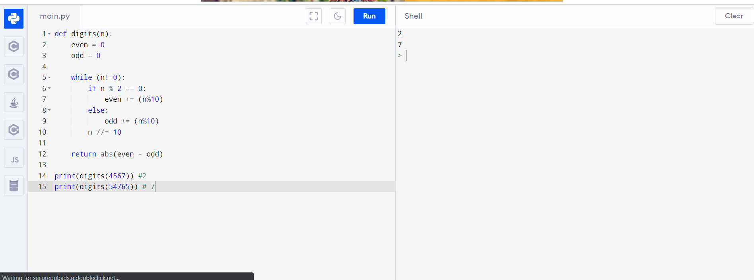

**11. Write a Python Program to make a Student class with proper attributes like roll_no, name, stream, and college.**

**Create two students and take input all details and show their information accordingly.**

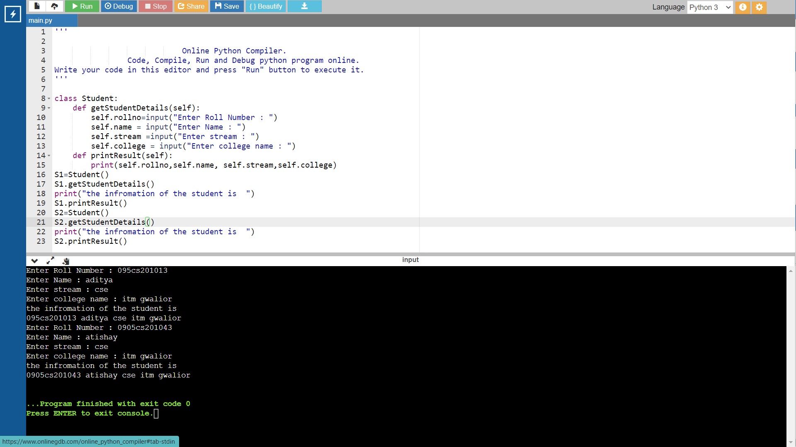

**12. Create a base class called Vehicle that stores number of wheels and speed. Create the following derived class:**

**Car that inherits Vehicle and also stores number of passengers.**

**Truck that inherits Vehicle and also stores the load limit.**

**Create objects of these classes and take user input and display all the information about Car and Truck. Also, compare the speed of the two vehicles.**

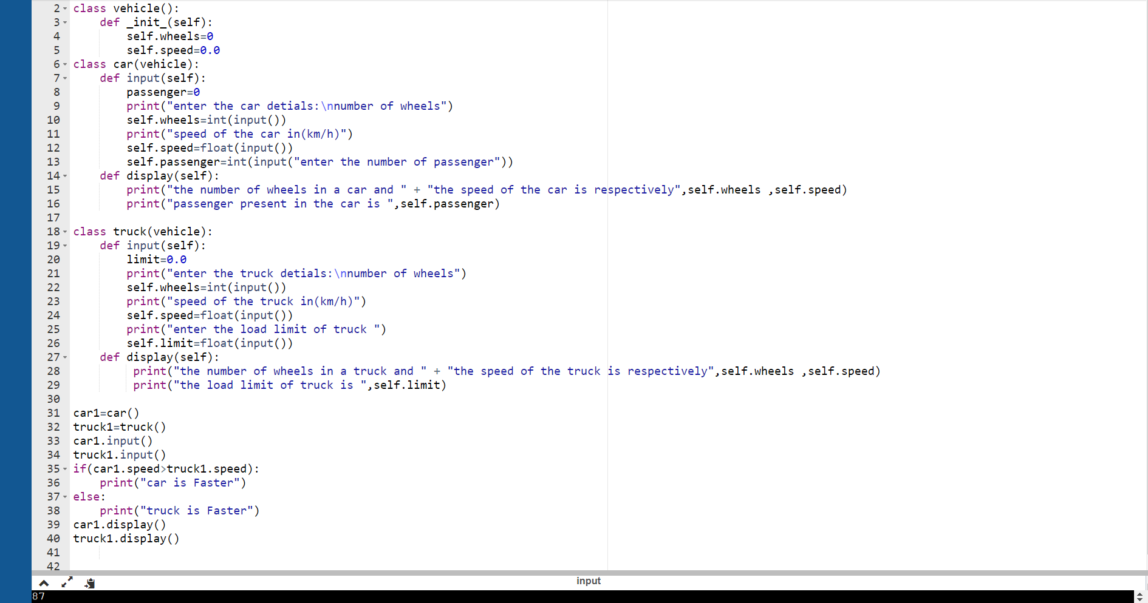

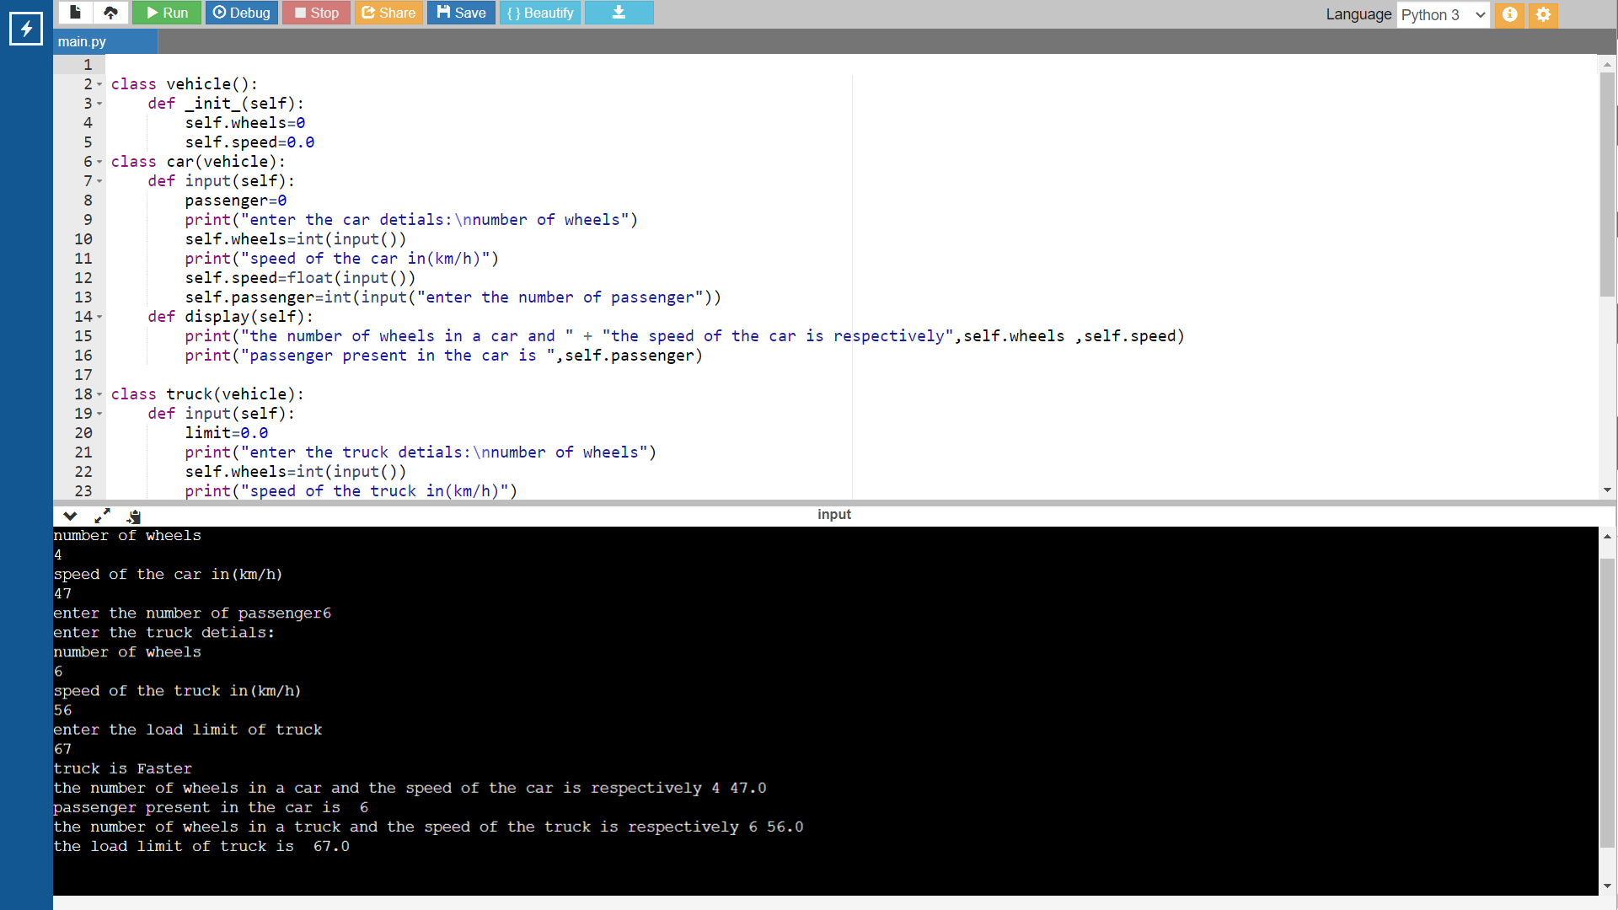

**13. Write a Python program to create a exception (provided the monthly salary of a person is less than Rs. 30,000 /-) and handle it.**

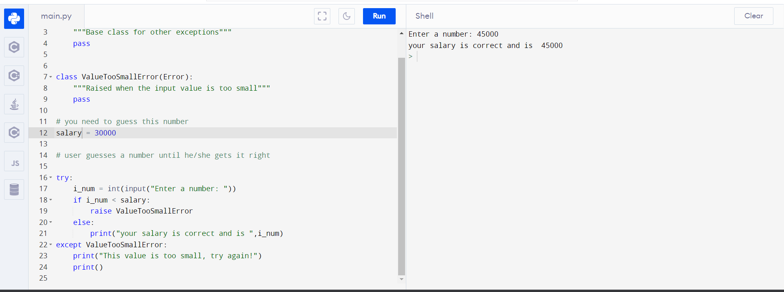

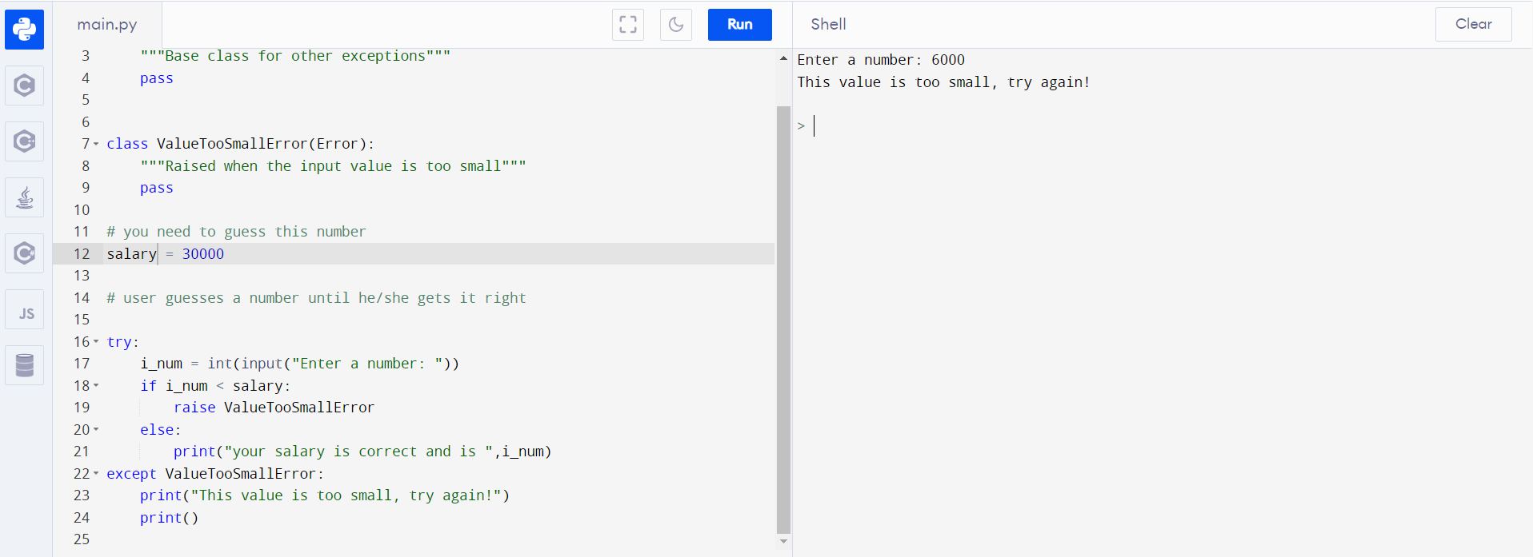

**Ques. 14: -- Read all information from a file and count no of word and display it.**

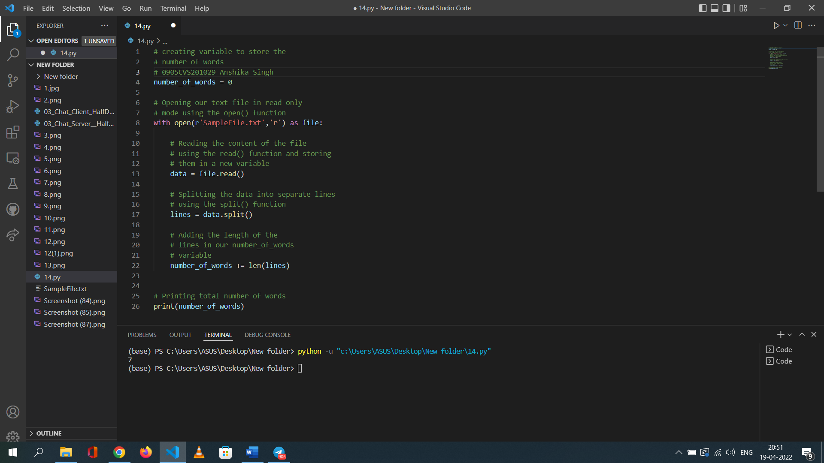

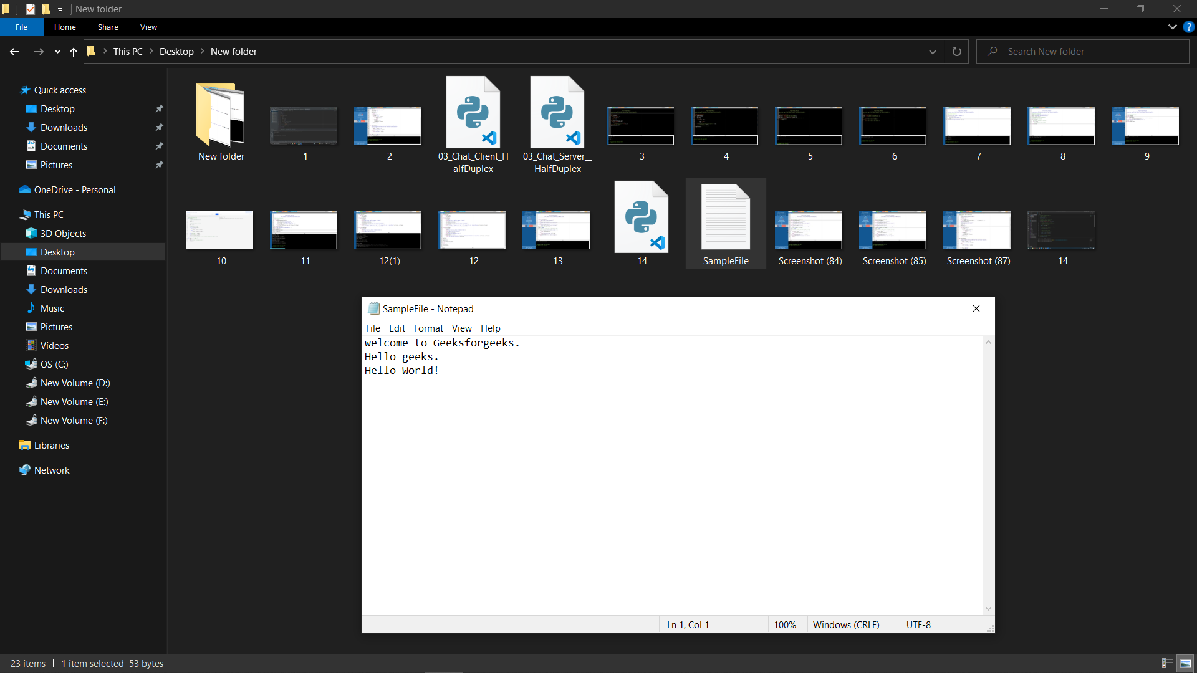

**Ques. 15:-- Write a program to create a basic Chat Application**

